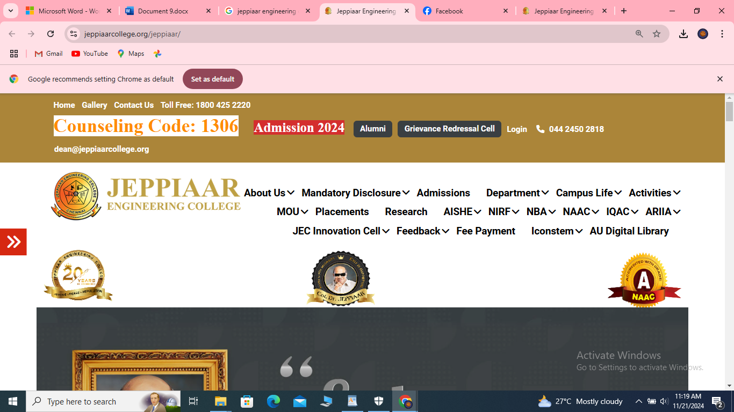

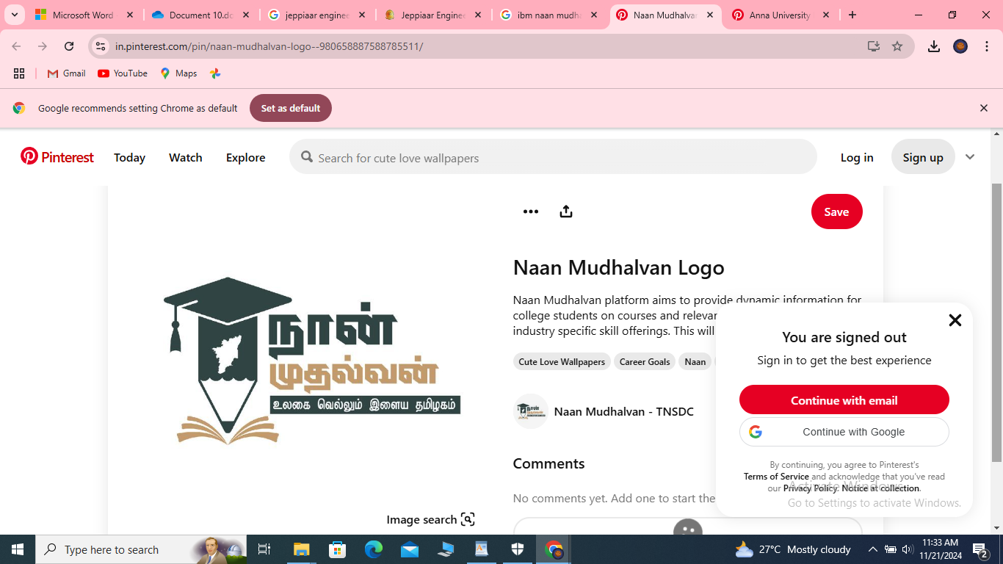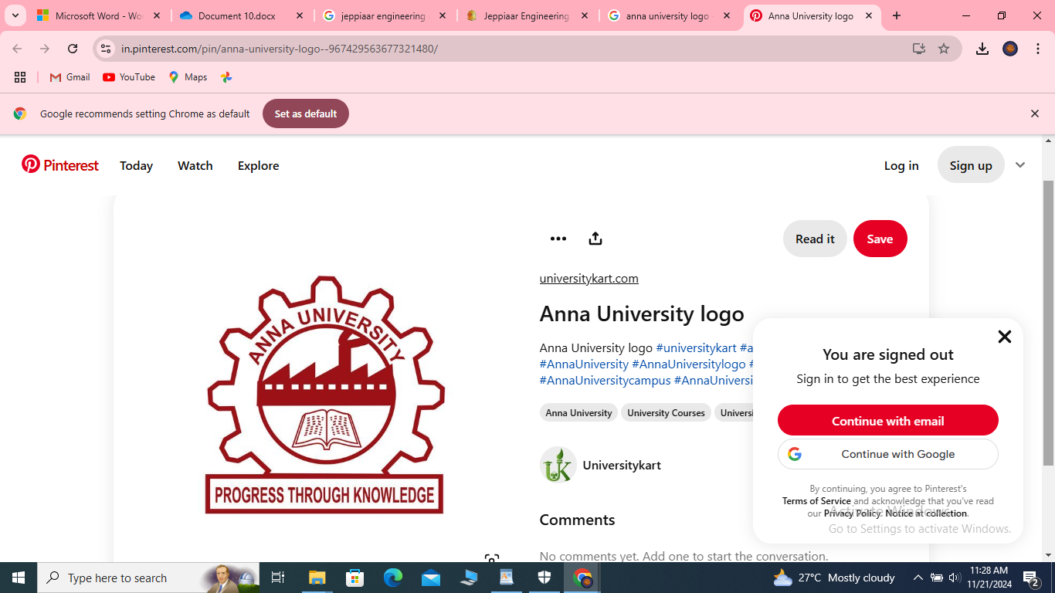

**BOOK A DOCTOR USING MERN**

**A PROJECT REPORT**

SUBMITTED BY

**Abinaya.M-310821205002**

**Abinesha.A-310821205003**

**Harini Devi.D-310821205028**

**Mathangi Siva Sundari.K -310821205044**

**BACHELOR OF TECHNOLOGY**

**IN**

**INFORMATION TECHNOLOGY**

**JEPPIAAR ENGINEERING COLLEGE ANNA UNIVERSITY CHENNAI-600025**

**NOVEMBER 2024**

**BONAFIDE CERTIFICATE**

This is to certify that the project report titled **" BOOK A DOCTOR USING MERN "** is the original work of **Abinaya.M-310821205002,Abinesha.A-310821205003,HariniDevi.D-310821205028,Mathangi Siva Sundari.K -310821205044** who successfully carried out the project under supervision.

**SUPERVISOR**  **HEAD OF THE DEPARTMENT**

**BHAGYALAKSHMI THIRUPPATHI**  **DR.ANITHA JAWAHAR**

***CONTENTS COVERED*:**

* **INTRODUCTION**
* **COMPONENTS**
* **SYSTEM FEATURES**
* **SYSTEM FEATURE ROLES**
* **TECHNOLOGIES USED**
* **SCENARIO BASED CASE-STUDY**
* **TECHNICAL ARCHITECTURE WITH OUTPUT SCREENSHOT**
* **CONCLUSION**

***INTRODUCTION:***

*The Doctor Appointment Booking System is a full-stack application built using the MERN stack. It aims to streamline the process of booking appointments, managing patient-doctor interactions, and maintaining appointment records. Booking a doctor's appointment has never been easier. With our convenient online platform, you can quickly and effortlessly schedule your appointments from the comfort of your own home. No more waiting on hold or playing phone tag with busy receptionists. Our user-friendly interface allows you to browse through a wide range of doctors and healthcare providers, making it simple to find the perfect match for your needs.*

*With our advanced booking system, you can say goodbye to the hassle of traditional appointment booking. Our platform offers real-time availability, allowing you to choose from a range of open slots that fit your schedule. Whether you prefer early morning, evening, or weekend appointments, we have options to accommodate your needs.*

***COMPONENTS REQUIRED:***

* *Hardware Required****:****Windows 8 machine*
* *Software Required:Install with two web browsers*
* *System Required:Bandwidth of 30mbps*

**SYSTEM FEATURES:**

**1. Frontend (React):**

**-** Interactive UI for patients, doctors, and admins.

- Components for booking, calendar integration, and feedback.

- Responsive design for mobile and desktop.

**2. Backend (Express & Node.js):**

- RESTful APIs for data communication.

- Authentication and authorization using JSON Web Tokens (JWT).

- Real-time updates for appointment status using WebSocket.

**3. Database (MongoDB):**

**-** Store patient, doctor, and appointment data.

- Flexible schema for future scalability.

- Search and filter capabilities for easy data retrieval.

**4. *Key Functionalities:\***

- Secure login and registration for all users.

- Real-time availability updates.

- Notifications via email or SMS for appointment confirmations and reminders.

- Feedback mechanism for patients to rate their experience.

***SYSTEM FEATURE ROLES:***

***1. Patients:***

***-*** *Browse available doctors and their specialties.*

*- View doctor availability.*

*- Book, cancel, or reschedule appointments.*

*- Access appointment history.*

***2. Doctors:***

*- Manage their schedule.*

*- Confirm, reschedule, or cancel appointments.*

*- Communicate with patients.*

***3. Admin:***

*-Manage user accounts (patients and doctors).*

*- Monitor system activity.*

*- Generate reports for usage and performance.*

***Scenario-based Case Study:***

***Scenario: Booking an Appointment with a Doctor***

***User Registration:*** *John, who needs to see a doctor for a routine check-up, visits the Book a Doctor app and signs up as a Customer. He provides his email and creates a password.*

***Browsing Doctors:*** *Upon logging in, John is presented with a dashboard displaying a list of available doctors and healthcare providers.He filters the list based on his preferences, such as specialty, location, or availability****.***

***Booking an Appointment:*** *John finds a suitable doctor and clicks on "Book Now." A form appears where he selects the desired appointment date and uploads any necessary documents, such as medical records or insurance information.After submitting the form, John receives a confirmation message indicating that his appointment request has been received.*

***Appointment Confirmation:*** *The doctor reviews John's appointment request and availability. Once confirmed, the appointment status changes to "scheduled."John receives a notification confirming his appointment and providing details such as the date, time, and location.*

***Appointment Management:*** *As the appointment approaches, John can view and manage his upcoming appointments in the booking history section of his dashboard.He has the option to cancel or reschedule appointments if needed and can update the status accordingly.*

***Admin Approval (Background Process):*** *In the background, the admin reviews new doctor registrations and approves legitimate applicants.Approved doctors are then registered in the app and can start managing their appointments.*

***Platform Governance:*** *The admin oversees the overall operation of the appointment booking system and ensures compliance with platform policies, terms of service, and privacy regulations.The admin addresses any issues or disputes to maintain a smooth user experience.*

***Doctor's Appointment Management:*** *be medication or recommend further treatment if necessary.John receives a visit summary and any follow-up instructions through the app.*

***TECHNICAL ARCHITECTURE WITH OUTPUT SCREENSHOT:***

*The technical architecture of our Book a Doctor app follows a client-server model, where the front end serves as the client and the back end acts as the server. The front end encompasses not only the user interface and presentation but also incorporates the Axios library to connect with the backend easily by using RESTful Apis.The front end utilizes the bootstrap and material UI library to establish a real-time and better UI experience for any user whether it is an admin, doctor, or ordinary user working on it.On the backend side, we employ Express.js frameworks to handle the server-side logic and communication. For data storage and retrieval, our backend relies on MongoDB. MongoDB allows for efficient and scalable storage of user data, including user profiles, for booking rooms, adding rooms, etc. It ensures reliable and quick access to the necessary information.Together, the frontend and backend components, along with Moment, Express.js, and MongoDB, form a comprehensive technical architecture for our Book a Doctor app. This architecture enables real-time communication, efficient data exchange, and seamless integration, ensuring a smooth and immersive booking of an appointment and many more experiences for all users.*

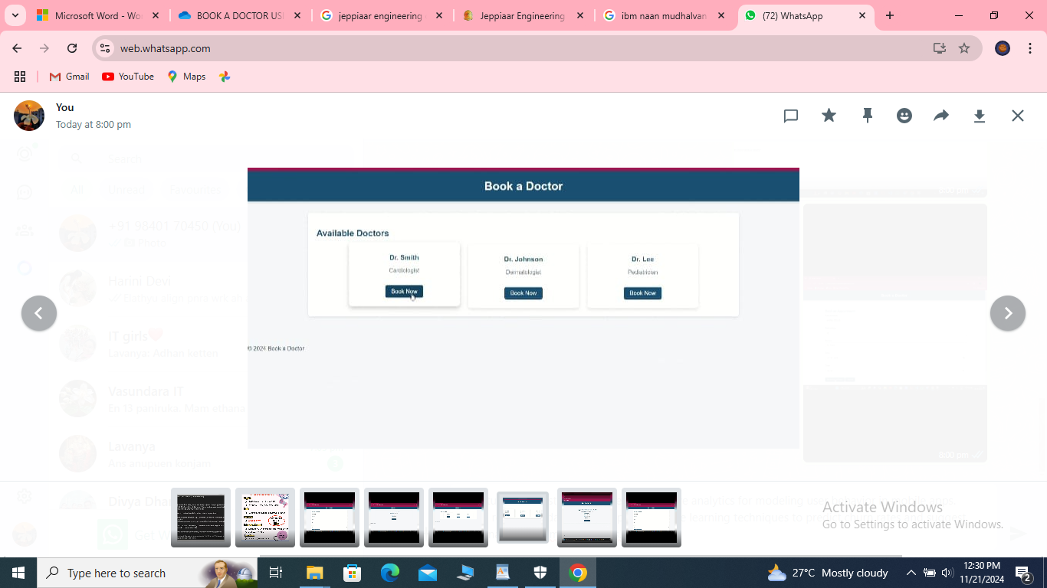

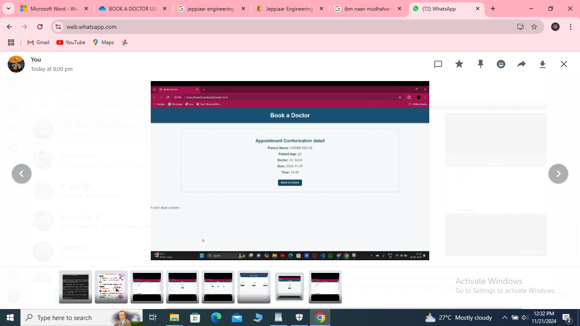

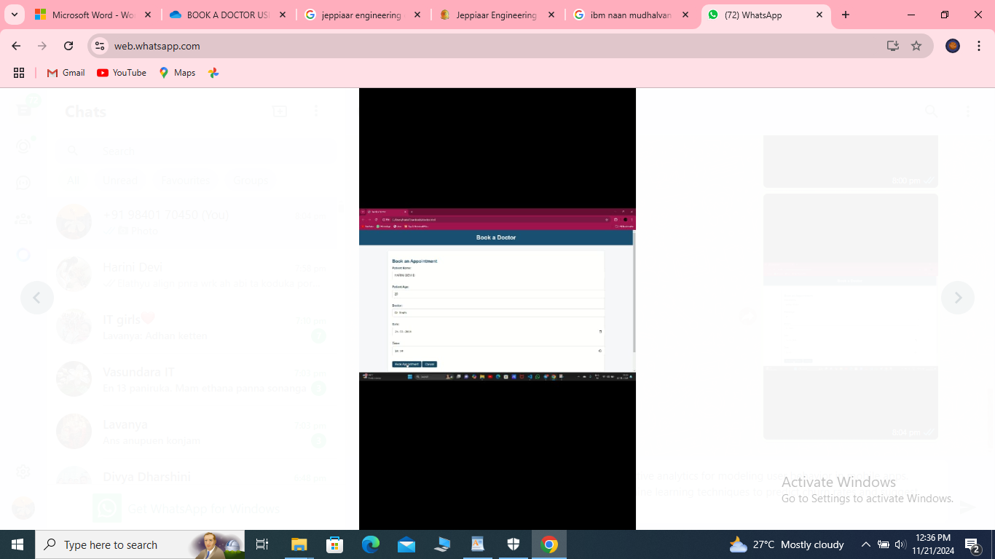

**CONCLUSION:**

*This MERN-based system offers an efficient and scalable solution for managing doctor appointments. It demonstrates the seamless integration of frontend and backend technologies to solve real-world challenges in healthcare.*